**Github Task:**

1. Create a git repository via Command Line

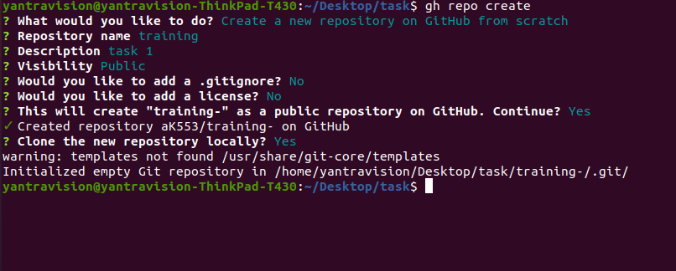

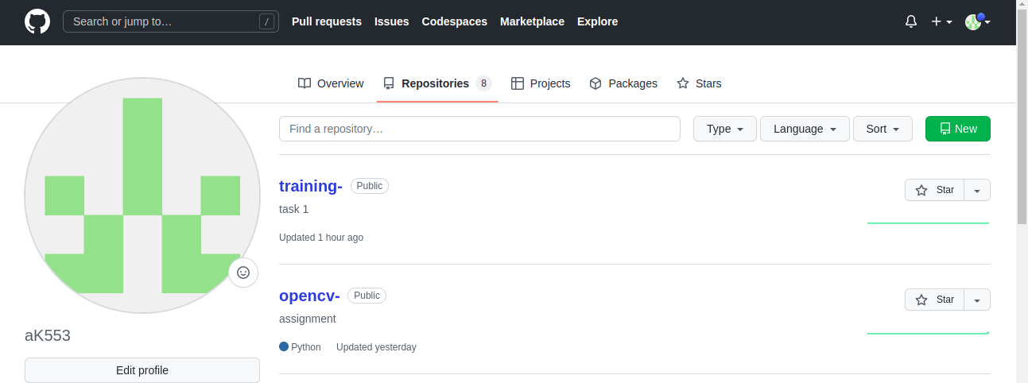

1. Create a README

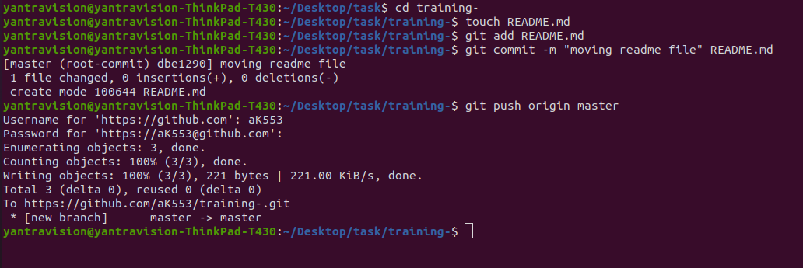

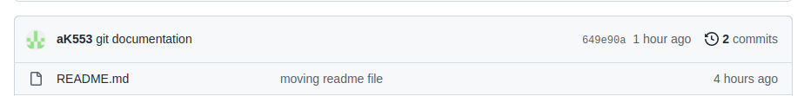

1. Create a branch “github_exercise” and push it to git repo

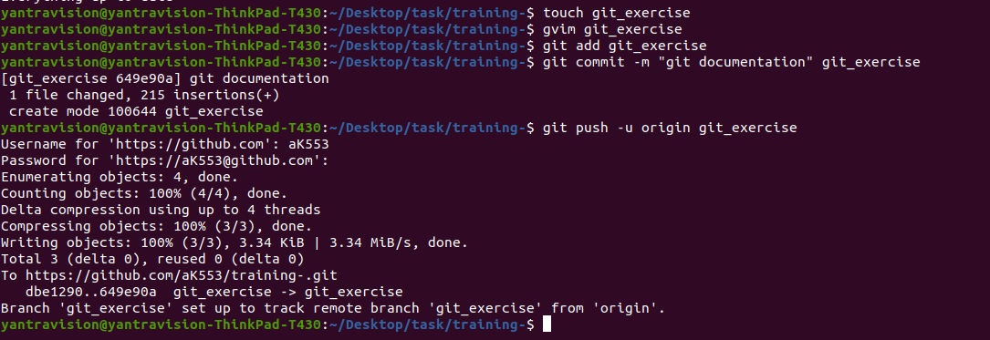

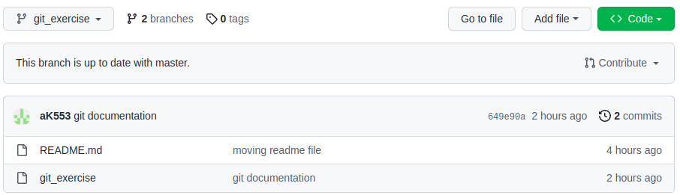

1. Create a Document on Github commands in “github_exercise” branch

<https://github.com/aK553/training-/blob/git_exercise/git_exercise>

1. Explore github flow

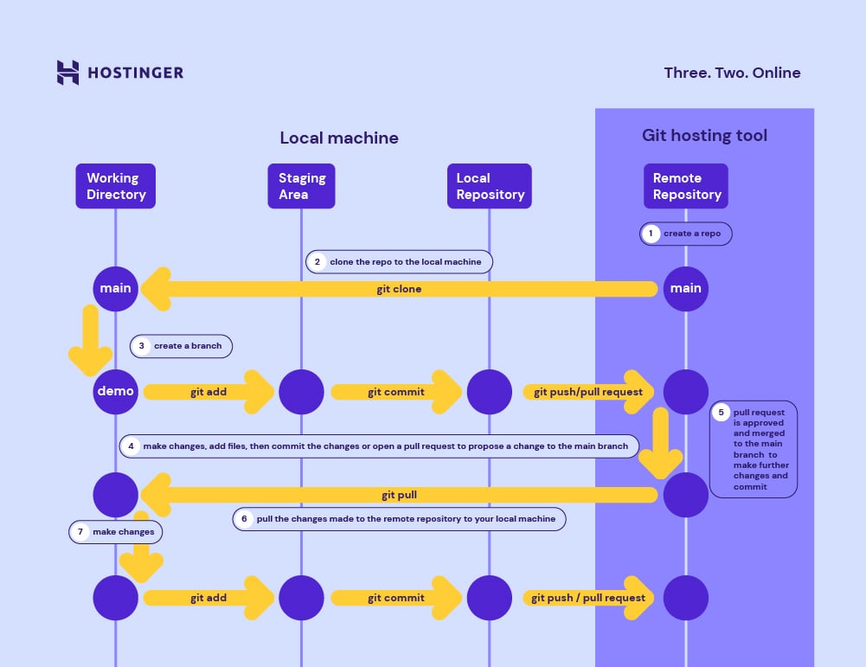

6.Merge “github_exercise” branch with master

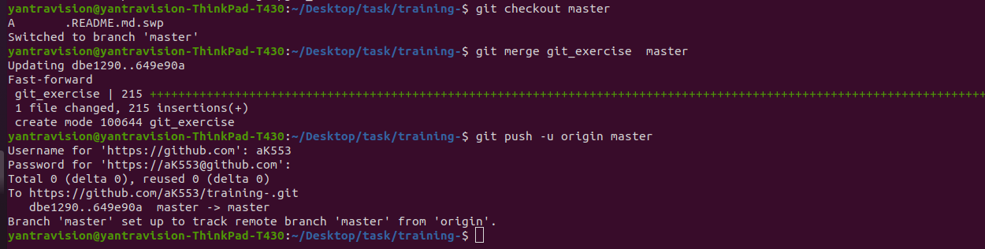

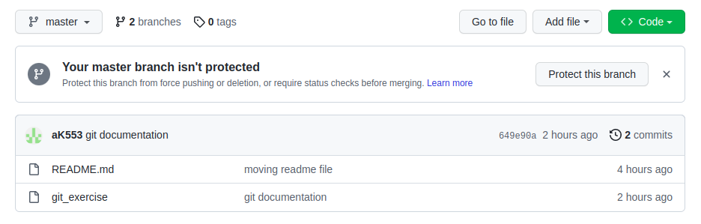

7. Explore git commands:

* 1. git rebase
  2. git remote
  3. git branch
  4. git rm

1. **git rebase**

Rebasing is the process of moving or combining a sequence of commits to a new base commit. Rebasing is most useful and easily visualized in the context of a feature branching workflow.

Checkout to the desired branch you want to rebase. Now perform the rebase command as

Command : **git rebase<branch name>**

1. **git remote**

The **git remote** command allows you to create, view, and delete connections to a remote repository.

**Command :git remote** // it shows the remote configuration ,list of remote connection that are in repositorie**s**

**git remote add <name> <url> //** to add a new remote repository connection

For example after adding the url

**git remote add new-remote https:/github.com/user/new-remote.git**

**git remote rename <old-name> <new-name> //** this command used to rename the remote connection

**git remote rm <name> //** it i used to delete the remote connection

1. **git branch**

In Git repo there will be a main and default branch, if we create a new branch means creating a new independent line , this branch will mirror the main branch ( its a copy of main branch)

***If main branch contents are changed,the copy of that branch will also change but if the contents of new branch is changed, no changes will be appear in the main branch***

*Command :*

**git branch_ branch name**

**git branch -a //** shows all available branch

**git switch -c <branch name> //**create new branch

**git branch //** will give the available branches

**git branch -d //** combines two branch

**git branch --show-current //** this command shows the current branch.

1. **git rm**

The **git rm –cached** command removes a file from the index, but it will remain intact in the working directory. This is useful if you plan to add it back to your Git repo in the future.

There are two ways to clear your cache using the **git rm –cached** command, depending on whether you’re going to remove specific files only or you want to clear an entire directory.

It removes a file from the index, but it will remain intact in the working directory.

There are two ways to remove

1. Remove specific files only
2. clear an entire directory.

Command : **git rm --cached <file name with extension>** // this command will remove a cache in specific file

**Git rm -r --cached <directory name>** // entire directory from index

9.Create a Pull Request from Fork to original repo and merge the changes

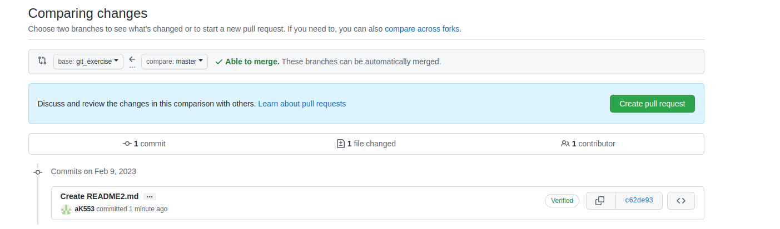

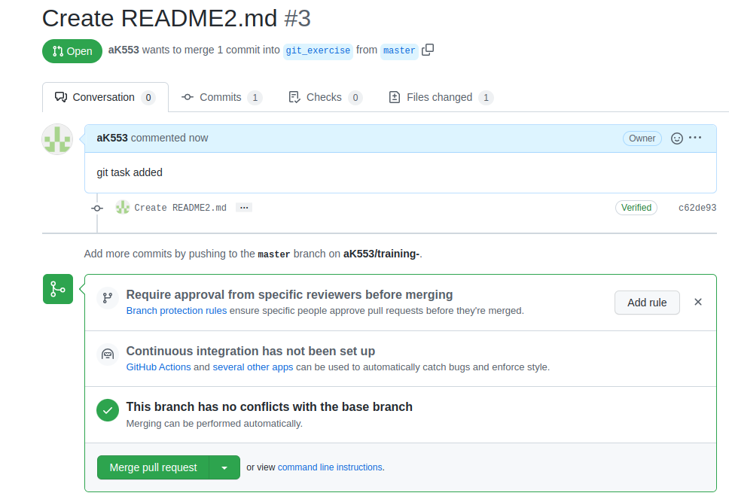

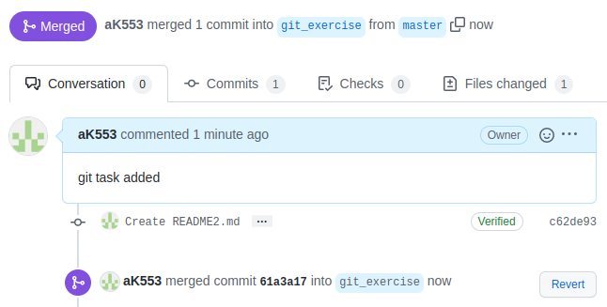

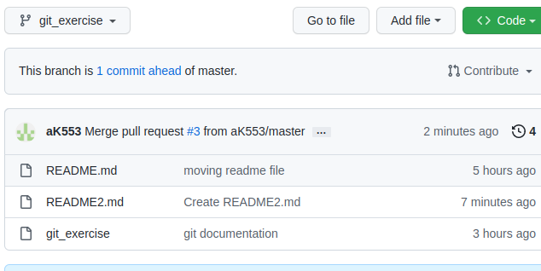

10. Explore issues creation and closure

